PROJECT DOCUMENTATION
Project Title: PRODUCT INVENTORY MANAGEMENT SYSTEM

Team ID: SWTID-2026-7912
Team Leader:
- Akshaya. M- 24csakshaya004@gmail.com
Team Members:
- Abinaya. A- 24csabinaya001@gmail.com
- Abirami. S- 24csabirami002@gmail.com
- Afrin. Z - 24csafrin003@gmail.com

Project Overview
The Product Inventory Management System is a backend-focused web application developed using Node.js, Express.js, and MongoDB, designed to provide a secure and scalable solution for managing product data through RESTful APIs. The system enables users to create accounts, log in securely, and access protected routes using JWT-based authentication, ensuring that only authorized users can perform operations. It supports complete CRUD functionality, allowing users to add new products, view their inventory, update product details such as price or quantity, and delete items when needed.

Key objectives:
- Ensure user-specific data isolation so each user can manage only their own products.
- Implement scalable backend architecture using Node.js, Express.js, and MongoDB.
- Deliver fast and reliable API responses with proper validation and error handling.
- The system minimize human mistakes by automating inventory calculations and record keeping.

Target Users:
• Small business owners managing product stock and inventory records.
• Freelancers or sellers tracking items or services in a structured way.
• Warehouse staff updating products entries and stock movements.
• Students working on backend or full-stack development projects.
• Developers learning backend API development and authentication workflows.
• Administrators maintaining product details and inventory data.

PROJECT INSTRUCTION:
• Create backend project folder
• Configure server using Express.js
• Setup MongoDB database connection
• Implement authentication APIs
• Implement product CRUD APIs
• Test APIs using Thunder Client in VS Code

PRE-REQUISITES
Software | Purpose
Node.js | JavaScript runtime for backend
MongoDB | Database storage
npm | Package manager
VS Code | Development environment

Knowledge Requirements
• JavaScript ES6 concepts
• Node.js and Express.js REST API development
• MongoDB and Mongoose ODM
• JWT authentication
• Middleware architecture
TECHNICAL ARCHITECTURE

Backend Architecture (Node.js + Express)
• Controllers: Handle authentication and product logic
• Models: Define database schema
• Routes: API endpoints for authentication and products
• Middleware: JWT verification and error handling
• Configuration: Environment variables and database connection

Database Architecture (MongoDB)
Features:
- It give a clear instructions with photos or video for step.
- A well-organized collection of recipes (by cuisine, meal type, difficulty level, etc.)
- It Automatically creates a shopping lists from selected recipes.
- Display calories and nutrients for each recipes.
- User can search recipes by ingredients, time, or dietary needs.
- It save the favorite recipes for quick access.

Users Collection:
•_id
•name
•email
•password(hashed)
• timestamp
Products Collection:
• _id
• user id (reference to user)
• name
• price
• quantity
• description
• timestamps
Relationship: One User → Many Products
Indexes:
•email(unique)
•userid
• product name

FEATURES:

Core Features
S.No | Feature | Description
1 | User Authentication | JWT-based register and login system
2 | Product CRUD | Add, view, update and delete products
3 | Private Data Access | Users access only their own products
4 | Product Search | Search products by name
5 | Secure API | Middleware protected routes

ROLES AND RESPONSIBILITY:
User
Registration: Register using name, email and password
Login: Login using registered credentials
Administrator: Monitor inventory reports and stock levels
Add Product: Create product with name, price, quantity and description.
Edit Product: Update existing product.

User Flow
- The user sends a register & login request.
- The system display product details and inventory status.
- The user sends a token in the authorization header.
- The user views stock levels and product availability.
- MongoDB stores or retrieves product data.
- API sends response.

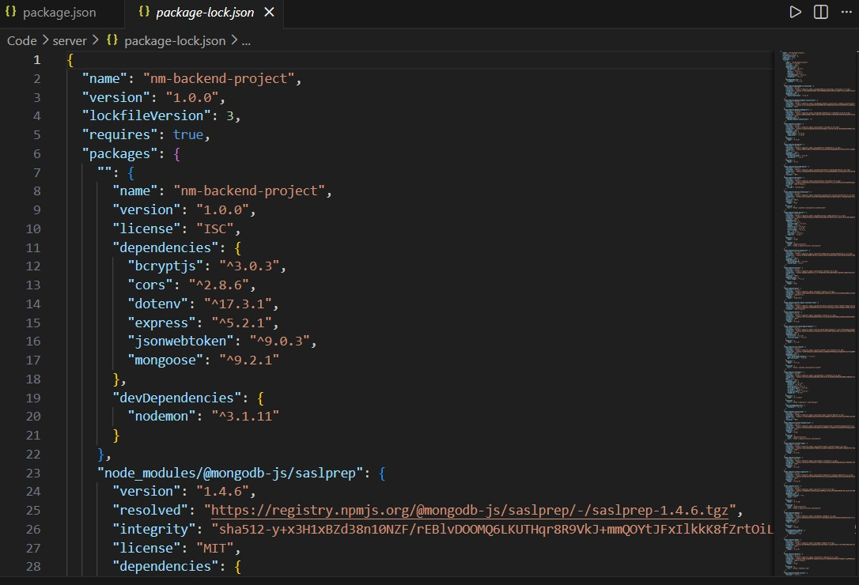

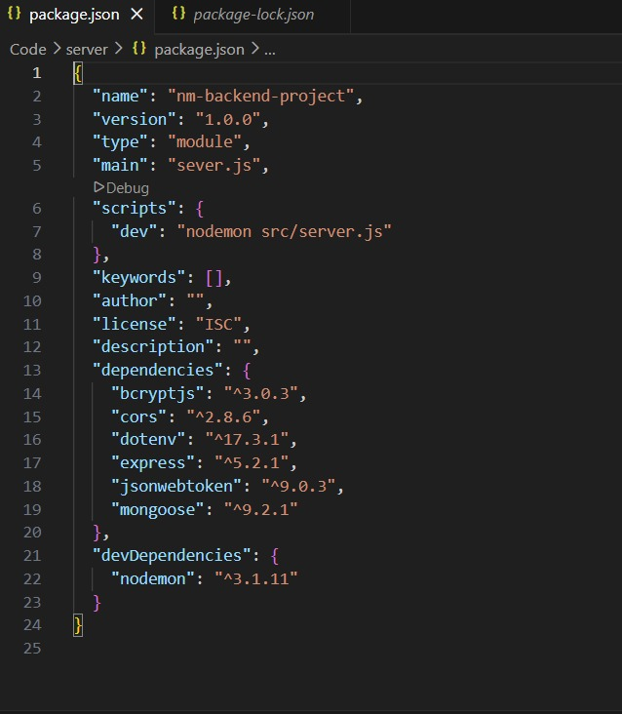

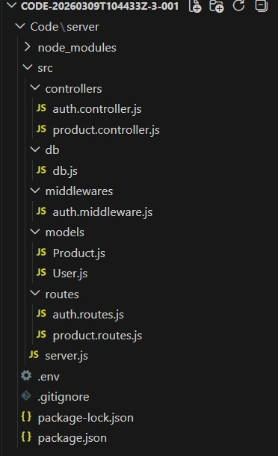

INSTALL REQUIRED PACKAGES:
Package Purpose:
- express → Backend framework
- mongoose → MongoDB connection
- cors → Cross-origin requests
- dotenv → Environment variables
- jsonwebtoken → Authentication
- bcryptjs → Password hashing

AUTH CONTROLERS:
The Auth Controller manages all user authentication-related operations in the system. It handles user registration and login functionality while ensuring secure access using JWT tokens.

Responsibilities:
- Register new users.
- Validate user input data.
- Hash passwords using bcrypt before storing.
- Authenticate users during login.
- Generate JWT tokens for authorized access.
- Send appropriate success and error responses.

Main Functionalities:
- Register User: Creates a new user account after validating email uniqueness and encrypting the password.
- Login User: Verifies credentials and returns a JWT token for protected API access.

EXAMPLE CODE FOR AUTH CONROLLERS:

const express = require('express');
const bcrypt = require('bcryptjs');
const jwt = require('jsonwebtoken');

const app = express();
app.use(express.json());

// Mock user (replace with DB lookup)
const user = {
id: 1,
username: 'user1',
password: '$2a$10$7qz...hashed_pw' // Replace with a real hashed password
};

// Login route
app.post('/login', async (req, res) => {
const { username, password } = req.body;

// Check user
if (username !== user.username) {
return res.status(400).json({ message: 'Invalid username or password' });
}

// Compare passwords
const isMatch = await bcrypt.compare(password, user.password);
if (!isMatch) {
return res.status(400).json({ message: 'Invalid username or password' });
}

// Generate token
const token = jwt.sign({ id: user.id, username: user.username }, 'secretKey', { expiresIn: '1h' });
res.json({ token });
});

// Protected route example
app.get('/products', (req, res) => {
const authHeader = req.headers.authorization;
if (!authHeader) {
return res.status(401).json({ message: 'No token provided' });
}

const token = authHeader.split(' ')[1];

try {
jwt.verify(token, 'secretKey');
res.json({ message: 'Protected route accessed' });
} catch (error) {
res.status(401).json({ message: 'Invalid token' });
}
});

app.listen(3000, () => {
console.log('Auth server running on port 3000');
});

BENEFITS OF AUTH CONTROLLER:
- Handle user-specific actions like login, registration and password verification.
- Validate user credentials against the database.
- Generate authentication tokens(e.g JWTs)after successful login.
- Manage user registration, such as creating new accounts or updating user info.

AUTH MIDDLE(PROTECT):
The Auth Middleware secures protected routes by verifying the JSON Web Token (JWT) sent in the request header. It checks for a valid Authorization header starting with "Bearer " and validates the token using the secret key. If the token is valid, the decoded user information is attached to req.user and the request proceeds to the next controller.

BENEFITS OF AUTH MIDDLEWARE:
- Acts as a gatekeeper to protect routes by checking for valid tokens.
- Ensures all protected routes verify user authentication before proceeding.
- Reduces repetitive code by centralizing token validation logic.
- Allows easy enforcement of role-based access (e.g., only admins can access certain routes).

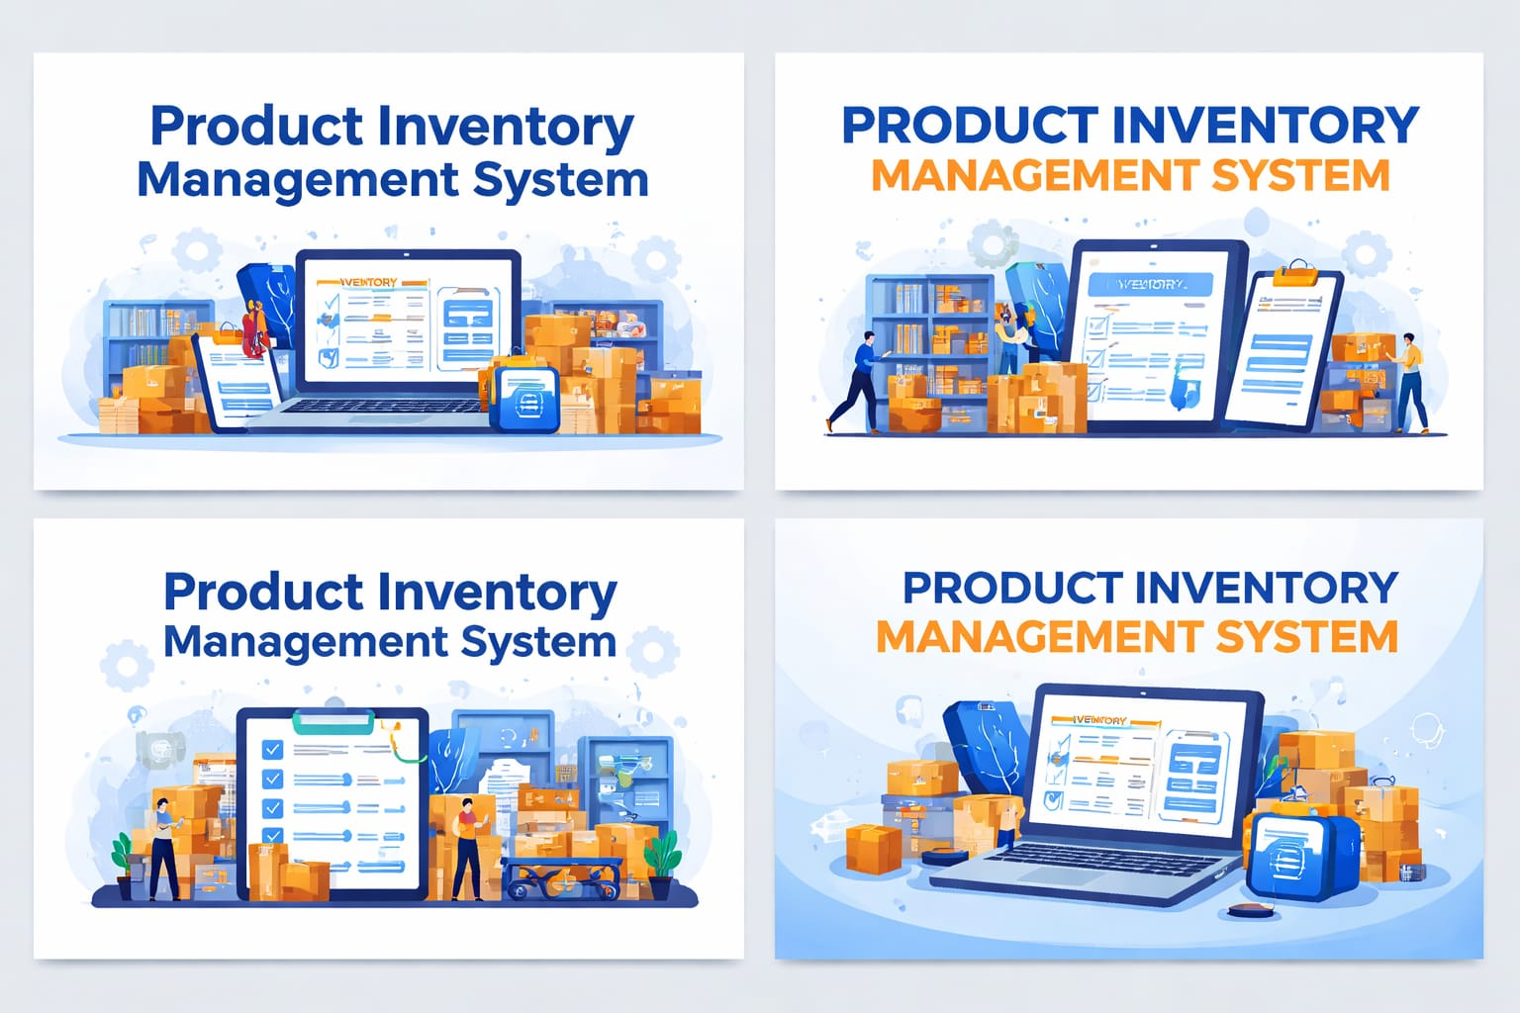

DATABASE CONFIGURATION AND SETUP:
- Create MongoDB Atlas cluster.
- Add connection string to .env .
- Connect DB before API testing.

Database Connection:
Create a file inside: src/db/db.js
Purpose: Connect backend to MongoDB using mongoose.

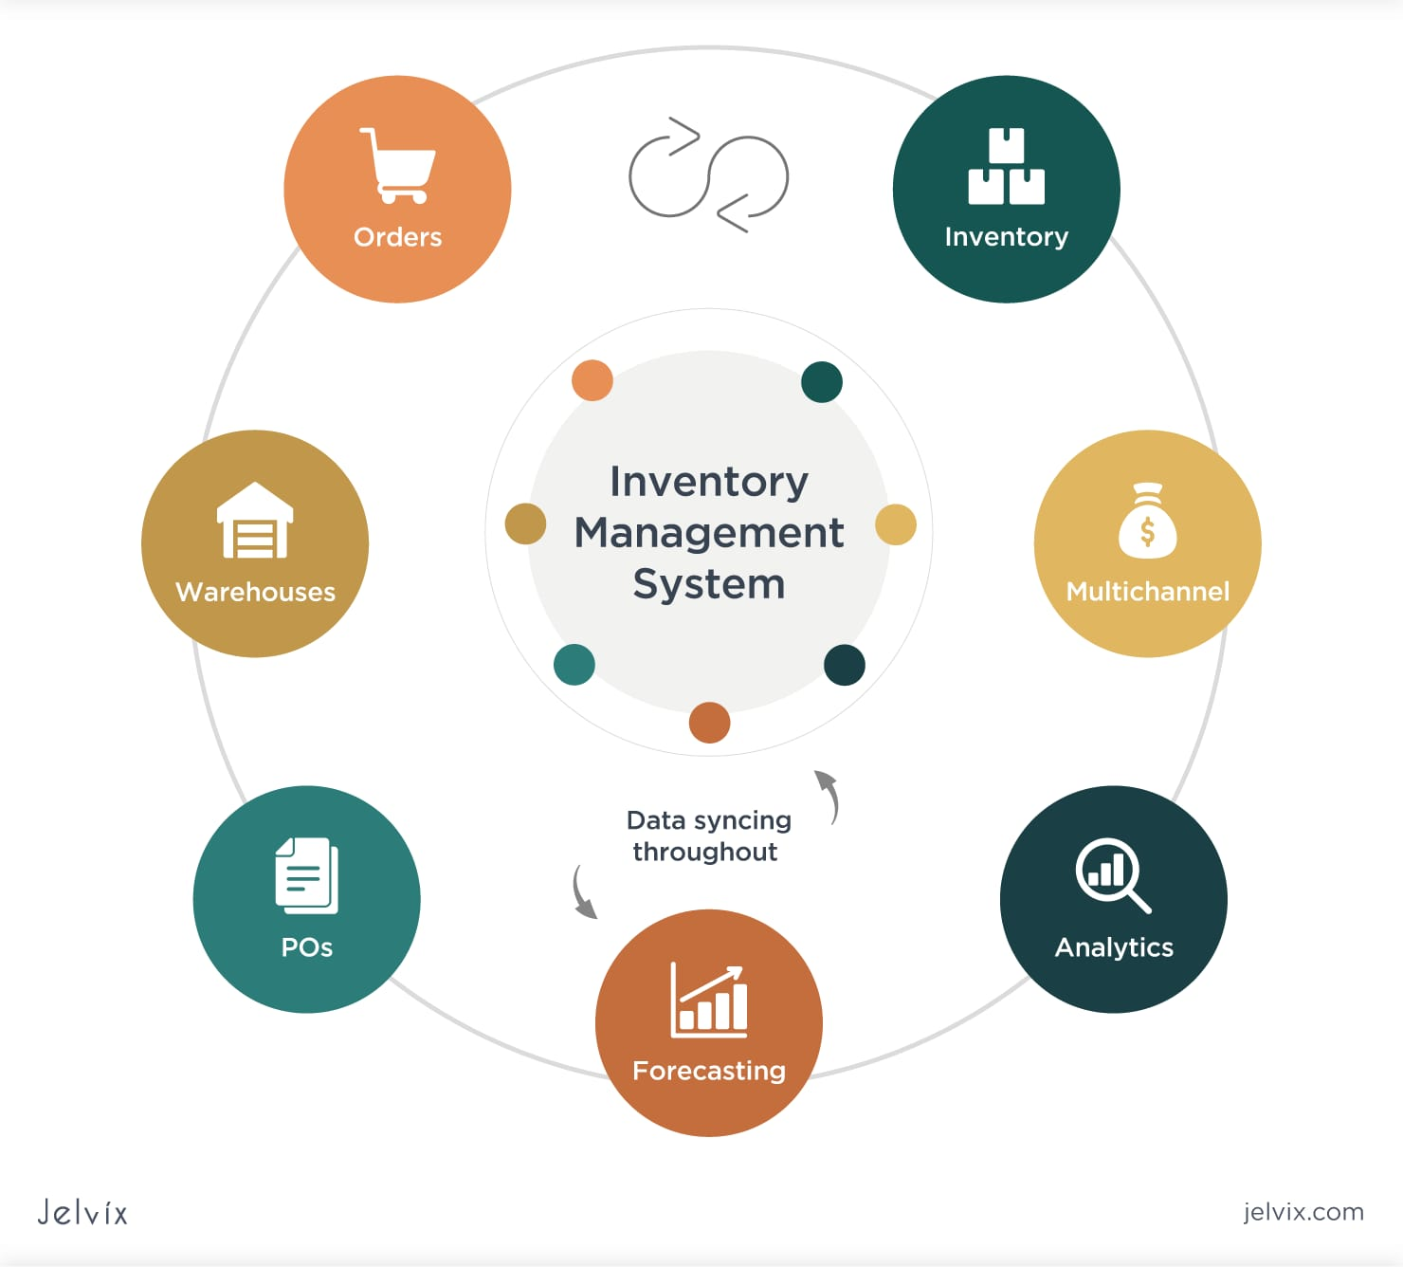

The connectDB function establishes a connection between the application and MongoDB using Mongoose and environment-based configuration. It ensures the server starts only after a successful database connection and logs an error message if the connection fails.
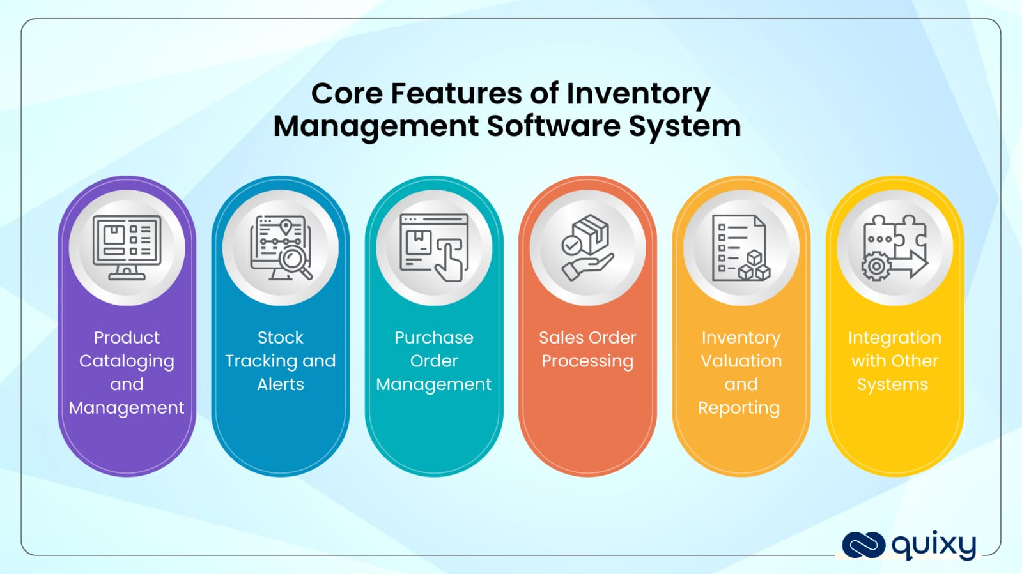

BACKEND DEVELOPMENT:
Backend development refers to the server-side logic and processes that power applications. It involves building and managing databases, servers, APIs, authentication, and business logic, ensuring data flows securely and efficiently between the user interface and the database.
The backend development can be broken into few key types
- API Development – Building RESTful or GraphQL APIs to connect frontend and backend.
- Database Management – Designing, querying, and optimizing databases like MongoDB, SQL, etc.
- Authentication and Authorization – Managing user logins, permissions, and secure access to resources.
- Business Logic – Implementing rules and processes for things like stock calculations, order processing, etc.
- Real-time Services – Using tools like WebSockets for live updates, such as real-time stock changes.

EXAMPLE CODE:
const express = require('express');
const mongoose = require('mongoose');

const app = express();

// Connect to MongoDB
mongoose.connect('mongodb://localhost:27017/inventoryDB');

// Define Product schema
const productSchema = new mongoose.Schema({
name: String,
quantity: Number
});

const Product = mongoose.model('Product', productSchema);

// Get all products
app.get('/products', async (req, res) => {
const products = await Product.find();
res.json(products);
});

app.listen(3000, () => {
console.log('Server running on port 3000');
});

BENEFITS OF BACKEND DEVELOPMENT:

- Data Management – Backend handles storing, retrieving, and managing data efficiently in a database.

- Security – It ensures secure handling of sensitive data, like user credentials and transactions.

- Business Logic – Backend implements rules and workflows that drive core functionality (e.g., stock calculations).

- Scalability – A well-built backend allows the system to grow, handling more users and requests without performance loss.

Integration – Backend connects to third-party services (e.g., payment gateways, external APIs), enabling a richer application.

- Performance – Offloading heavy logic to the backend ensures faster and more efficient client-side performance.


PRODUCT CONTROLLER:
A product controller in a product inventory management system is a backend component that manages all operations related to products. It handles tasks such as creating new products, updating product details, deleting products, and retrieving product information. Essentially, it acts as the bridge between the application’s business logic and the product data in the database.

Responsibilities:
- Add new products to inventory.
- Fetch products belonging to logged-in users.
- Update product details like price, quantity, or description.
- Delete products securely.
- Perform product search functionality.

Main Functionalities:
- Create Product: Adds a new product with a reference to the authenticated user.
- Get Products: Retrieves only the products created by the logged-in user.
- Update Product: Modifies product details while verifying ownership.
- Delete Product: Removes a product safely from the database.
- Search Product: Allows filtering products based on name.
BENEFITS OF PRODUCT CONTROLLER:
- Centralized Product Management- It manages all product-related operations like adding, updating, and deleting products in one place.
- Efficient Data Handling- It helps retrieve and store product information from the database quickly and efficiently.
- Improved System Organization- By separating product logic from other parts of the system, the application becomes more organized.
- Easy Maintenance- Developers can easily update or modify product-related functions without affecting other modules.
- Better Data Accuracy- It ensures correct handling of product details such as quantity, price, and category.
- Supports Inventory Tracking- It helps track product stock levels and maintain accurate inventory records

PRODUCT ROUTES:
A Product Route in a Product Inventory Management System is a backend path or endpoint that allows the application to perform operations related to products. It connects user request for managing product data such as adding ,viewing ,updating and deleting products.
TYPES OF PRODUCT ROUTES
- GET Route- Used to retrieve or view product data from the database.
Example: Get all products.
- POST Route- Used to add a new product to the inventory.
3. PUT Route- Used to update existing product details such as price or quantity.
4. DELETE Route- Used to remove a product from the inventory system.

BENEFITS OF PRODUCT ROUTE:
- Efficient Product Operations- Product routes help perform actions like adding, viewing, updating, and deleting products easily.
- Better System Organization- They separate product-related requests from other parts of the system.
- Improved Data Management- Product routes allow the system to communicate with the database to manage product data.
- Easy Integration with Frontend- Frontend applications can easily send requests to product routes to get or update product information.
- Faster Request Handling- They help the backend process user requests quickly and return the required product data.
- Scalable System Design- Product routes make it easier to expand the system by adding more product features in the future.

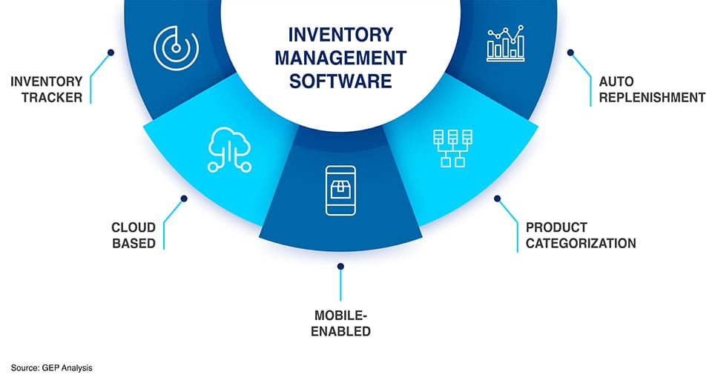

THE INVENTORY MANAGEMENT SOFTWARE:
- Inventory Tracker- Helps businesses track and monitor the quantity of products available in stock.
- Auto Replenishment- Automatically updates stock levels and notifies when products need to be restocked.
- Product Categorization- Organizes products into different categories to make searching and managing easier.
- Mobile-Enabled- Allows users to access and manage inventory using mobile devices from anywhere.
- Cloud-Based- Stores data in the cloud so it can be accessed securely anytime and from any location.

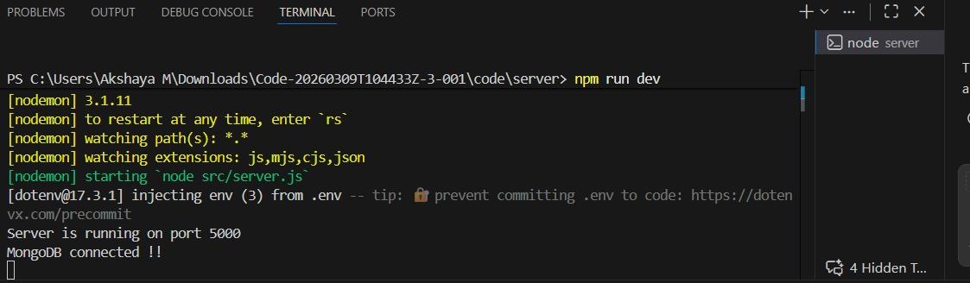

CONCLUSION:
The Product Inventory Management System helps businesses manage and monitor their product stock in an efficient and organized manner. It reduces manual work, improves data accuracy, and makes inventory tracking easier. By using backend technologies and a database, the system can store, update, and retrieve product information quickly. Overall, this system improves stock management, saves time, and helps businesses maintain better control over their products and inventory operations.

